Drupal installation Steps

1) Install XAMPP from https://www.apachefriends.org/download.html. In this select the installer, if ubuntu, go for xampp for linux. Download it and install it.
2) Now download drupal from https://www.drupal.org/download.
3) Now extract the zip file and copy it in htdocs in computer/opt/lampp/htdocs folder.
4) Start Xampp by opening the terminal and type sudo opt/lampp/lampp start and confirm it by entering the system password
5) Now open browser and type localhost/phpmyadmin to open the database.
6) Create a database with drupalsample name or any name.
7) Now open another tab and type localhost
8) In this, click on drupal folder. It will start a installation wizard.
9) Click on Next and Next.
10) Now there are two errors, first is about write permissions. So for this, open terminal and move to path opt/lampp/htdocs and give drupal folder read and write permissions by typing this:
sudo chmod R 777 drupal-9.3.0

11) To solve second error, open opt/lampp/htdocs/drupal-9.3.0/sites/default. Now there are two files here, copy default.settings.php and create another copy of it and rename that copy as settings.php
12) Now click on retry in installer, your problem is resolved.
13) Now click on continue anyway to go to next screen
14) In this screen, enter the name of the database that you have created in phpmyadmin i.e. drupalsample and also database username will be root and database password will be empty.
15) After that click on save and continue
16) Now it will start installing drupal and take some time
17) Now configure your site by adding site name, site emailid, username, password, emailid, country and timezone and click on save and continue.
18) Now the admin panel will be opened..

If you are having this warning while Installing theme or Module on Drupal
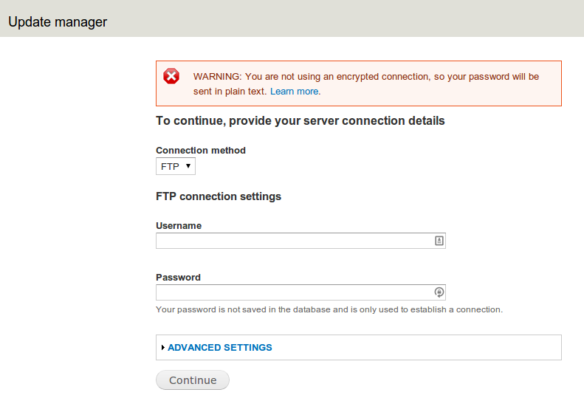
SOLUTION :
STEP 1 : Open Terminal(Ctrl+Alt+T)
STEP 2: You need to provide Permission to drupal/Sites , Just simply type in terminal given below:
sudo chown www-data:www-data -R /opt/lampp/htdocs/drupal-9.3.0/sites

Here drupal-9.3.0 is my drupal directory name , and /opt/lampp/htdocs is its path . You should write directory name according to it is written in your System.
STEP 3: Now go to drupal and install Theme or module .
STEP 4: If it asks for username and password, Enter your system username and password.

If you want to login in Drupal Admin, then the url will be
http://localhost/drupal-9.3.0/user/login

To add Contact Us Page, you need to add two modules
1) Contact Storage
2) Token

If your drupal website is showing “The website encountered an unexpected error. Please try again later.” and you want to know the cause of error.

Open setting.php in /opt/lampp/htdocs/drupal-9.3.0/sites/default

and add this line.

$config['system.logging']['error_level'] = 'verbose';

